

Semaphore Short Friday 10 July 2026

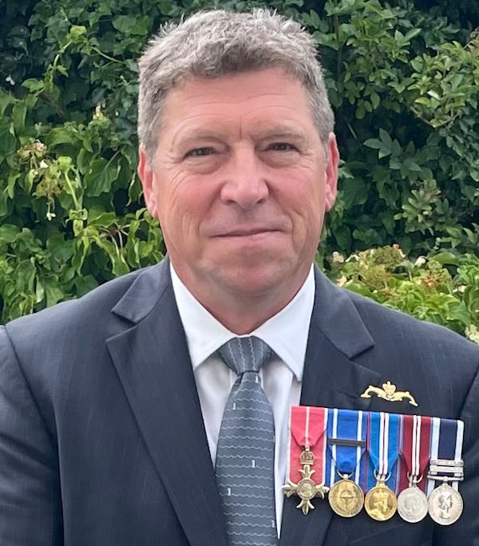

RNA appoints new General Secretary

Following a thorough recruitment process, Andrew (Andy) Coles (pictured above) has been appointed to the post of GS/Chief Executive Officer, and will take up the role on 7 September.
Andy served for 38 years in the Royal Navy, rising to the rank of Commander, and commanded submarines HMS Turbulent and HMS Astute. He was also Base Commander of HMS Drake in Devonport.
Andy is an Officer of the Most Excellent Order of the British Empire (OBE).
Since leaving the Service, he has built extensive leadership experience across the maritime industry, including marina operators.
As a member of our Cardiff Branch, Andy already understands the role and importance of the RNA and the difference our shipmates, volunteers and staff make every day.
We congratulate Andy on his appointment and look forward to welcoming him to the RNA family in the autumn.
Until then Kate Aldous will remain as our Interim GS/CEO. In recognition of Kate’s all-round contribution to the Association, she has been asked to take on the role of Deputy GS/CEO when Andy takes up the reins – a post we are delighted to say that she has accepted.

  What did you think of Salford 2026?
  The RNA is still keen to hear your views on the National Conference weekend in Salford last month.
  We are constantly striving to improve the programme for the annual gathering, and organising Branches and Areas welcome the guidance that comes from feedback by delegates, observers and other shipmates who attend Conferences.
  And we are not just looking for criticism or room for improvement – we welcome positive comments and suggestions which could add to the overall experience.
  Please fill in our feedback form – use the QR code right or click on this link to a mircrosoft form.
  

Shady business

It looks like we are in for a long, hot summer, so all shipmates are encouraged to consider how they might get some relief through the dog days of July and August.
We provided a brief overview of the problems and some strategies for coping with high temperatures in the June edition of the Semaphore Circular (see page 24 at https://www.royal-naval-association.co.uk/semaphore-circular-june-2026) but you can find much more information on the government website at https://www.gov.uk/government/publications/beat-the-heat-hot-weather-adviceand on the Age UK website at https://www.ageuk.org.uk/information-advice/health-wellbeing/mind-body/staying-cool-in-a-heatwave/

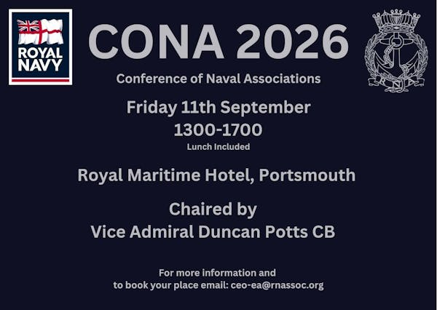

Conference call

There is still space for delegates to the CONA gathering in Portsmouth in September.
CONA – the Conference of Naval Associations – is a forum for representatives of Naval associations across the UK to network, share ideas, strengthen connections and discuss issues of importance to the wider Naval community.
Whether you are involved with an association, a Branch committee, or simply interested in the organisations that support the wider Naval family, CONA offers an opportunity to meet fellow members, hear from guest speakers and contribute to important discussions.
The meeting takes place at the Royal Maritime Hotel in Queen Street, Portsmouth on Friday 11 September between 1pm and 5pm – to book your place contact Milly on ceo-ea@rnassoc.org
Please note – delegates qualify for a ten per cent discount when booking a room at the Royal Maritime Hotel if they quote CONA.



Hoofing opportunities

Royal Navy families are being offered the chance to take part in a unique five-day wellbeing programme with HorseBack UK, helping to build confidence, strengthen relationships and create lasting memories together.
Running from 3–7 August and 17–21 August in the stunning surroundings of Royal Deeside in Scotland, the Family Week combines equine-assisted learning with a range of outdoor activities designed to support wellbeing, resilience and teamwork.
Founded by former Royal Marine Jock Hutchison, HorseBack UK has supported more than 700 members of the Armed Forces community since 2009.
Through working with horses and taking part in shared challenges, participants develop confidence, communication skills and self-awareness in a relaxed, supportive environment.
The week focuses on working alongside horses from the ground, with no previous horse experience required.
Families will also enjoy activities including bushcraft, archery, nature walks, arts and crafts, treasure hunts, games and visits to local attractions, while staying together in shared accommodation.
HorseBack UK’s programmes have helped participants improve their wellbeing, relationships and confidence, with many reporting lasting positive changes long after completing the course.
This is an opportunity for Royal Navy families to step away from the pressures of everyday life, reconnect with one another and enjoy a rewarding week in the Scottish countryside.
For more details of the course, accommodation, a kit list and what you can expect, you can download full joining information using https://www.royal-naval-association.co.uk/wp-content/uploads/2026/07/HorsebackUK.pdf

Are your Branch details out of date?

Have you checked to ensure that your Branch details are correct on the RNA website?
We suspect there might be at least one Branch that needs to let us know that there have been changes to meeting dates/times, because one disgruntled shipmate recently had a wasted journey to another Branch, arriving at the advertised time and location only to find no sign of shipmates and the venue closed.
Ideally, every Branch entry should have a correct time and place for their regular Branch meetings and a person to contact, which is often the Branch secretary.
Central Office does keep up-to-date records through processes such as annual returns, but we are not always promptly informed when meeting venues and dates change.
So, we are asking each branch to check their entry under the branches directory on the website (https://www.royal-naval-association.co.uk/branches) and let us know if anything needs to be amended or updated.
Please contact Central Office via email on comms@royalnavalassoc.com, using the message line ‘Update [name] Branch’, eg Update Slough Branch.
Communication is a vital part of the RNA’s business, so it is crucial that we make sure potential members, for example, can find what they need to know about a branch straight away – in some ways, outdated information is worse than no information at all.

Uckers World Championships is in the offing

With the World Cup approaching the semi-final stage, and Wimbledon finishing this weekend, how are shipmates going to fare when this bumper summer of cut-and-thrust sport and sheer edge-of-your-seat excitement is over?
Fear not – it is less than three months until the World Uckers Championships in the sporting crucible that is the Royal Maritime Hotel in Portsmouth.
How can you not be part of this festival of Naval boardgamesmanship?
The event takes place on Saturday 3 October, with registration between 0900 and 1000, after which all kinds of dice-related mayhem breaks loose around the tables.
Whether you’re a seasoned pro or just fancy your chances, we want to hear from you!
And please bring your families – this is an event for everyone.
To help us plan, please email Milly on ceo-ea@rnassoc.org to register your interest, including your name, contact details, and whether you are entering solo or with a teammate (or both!)

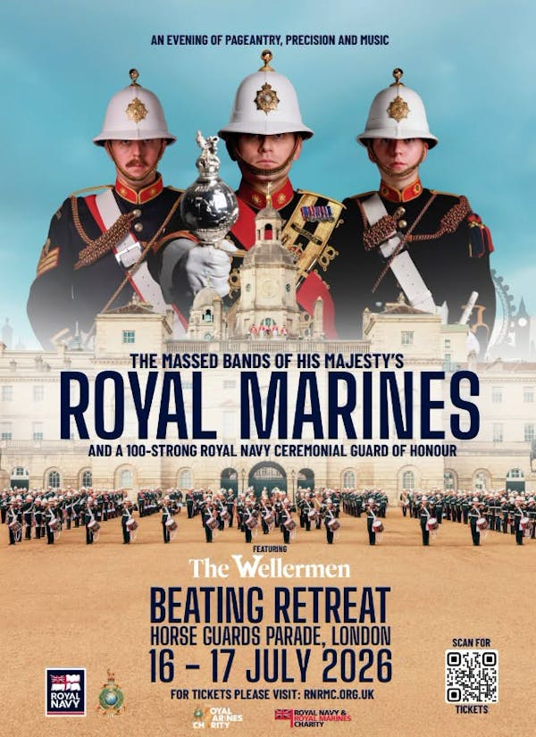

Tickets still available for military spectacular

Tickets are still available for a spectacular military show in London on 16 and 17 July in support of the RMA – Royal Marines Charity and Royal Naval & Royal Marines Charity (RNRMC).
Beating Retreat, on Horse Guards Parade, will feature more than 200 Royal Marines musicians, including the mesmerising precision drill of the Corps of Drums, a Royal Navy Guard of Honour and a Sunset Ceremony.
There is also a special guest appearance by folk group The Wellermen, whose modern take on maritime music and shanties has earned them a global following.
Tickets are available from £17 to £45, with seated, special access and wheelchair-accessible options available. To book, visit https://www.tickets.rnrmc.org.uk/navy-beating-retreat/

 |  |  |  |  |  |  |  |  |  |  | 

